JSON Refiner Advanced Edition
Professional JSON Processing Tool

- Introduction

Modern software applications depend heavily on structured data formats for communication between systems. Among these formats, JSON (JavaScript Object Notation) has become one of the most widely used data exchange formats in web services, APIs, configuration files, and cloud platforms.

However, handling JSON data often requires complex operations such as data transformation, validation, key standardization, and structural modification. These tasks are typically performed manually or through programming scripts, which can lead to errors and inefficiencies.

The JSON Refiner Advanced Edition project addresses these challenges by providing an intelligent platform that simplifies JSON data processing. The system integrates powerful Python libraries such as Gradio, Pandas, JSONSchema, and Transformers to provide automated JSON parsing, transformation, validation, and AI-based analysis.

The platform enables users to perform multiple JSON operations through an interactive web interface, making it accessible to both technical and non-technical users.

- Problem Statement

In modern organizations, JSON data is generated and exchanged across multiple systems including APIs, databases, configuration files, and analytics platforms. However, inconsistencies in JSON data structures often create several problems.
Common issues include:

- Inconsistent naming conventions across systems
- Incorrect or mixed data types
- Deeply nested structures that are difficult to analyze
- Lack of proper validation mechanisms
- Manual transformation of JSON data
- Traditional tools often require programming knowledge, which makes the process difficult for non-technical users and increases the chances of human errors.

The JSON Refiner system aims to solve these issues by providing automated JSON processing with intelligent features such as type detection, schema validation, structural transformation, and AI-based analysis.

- Objectives of the Project

The main objectives of the JSON Refiner system are:
To design and develop an intelligent JSON processing platform.
To automate the conversion of raw key-value text into structured JSON format.

To implement schema validation for ensuring JSON data integrity.
To support multiple key naming conventions such as:

- snake_case
- camelCase
- PascalCase
- kebab-case

To provide flattening and unflattening operations for nested JSON structures.
To integrate AI-based functionality for generating JSON summaries.
To develop an interactive user interface using Gradio.
- System Overview

The JSON Refiner system consists of several integrated modules that work together to process and refine JSON data efficiently.

The major components include:

- JSON Parsing Module
- Type Inference Engine
- Key Conversion Module
- Data Transformation Utilities
- AI Analysis Module
- JSON Validation System
- Web-Based User Interface

The system workflow follows these steps:

- User inputs raw data or uploads JSON
- System parses and validates the input
- Data transformation operations are applied
- AI-based analysis is performed
- Refined JSON output is generated

- Technology Stack

The JSON Refiner system is developed using modern technologies that support efficient data processing and interactive interfaces.
Programming Language

- Python (Version 3.8+)
- Python was chosen because it provides extensive libraries for data processing, machine learning, and web interface development.
- Libraries Used

- Gradio
- Gradio is used to develop the web interface that allows users to interact with the system through a browser.
- Pandas
- Pandas provides powerful data manipulation capabilities and is useful for handling structured datasets.

- JSONSchema
JSONSchema is used to validate JSON data structures and ensure compliance with predefined schemas.

- Transformers
- The Transformers library is used to load the Granite AI model, which generates summaries and suggestions for JSON structures.

- PyYAML
- PyYAML allows conversion between JSON and YAML formats and supports configuration data processing.

- System Architecture

System architecture refers to the overall design and structure of a software system. It defines how different components of the system interact with each other, how data flows through the system, and how the system performs its core functionalities. A well-designed system architecture ensures scalability, reliability, maintainability, and efficient performance.

In a typical JSON processing or data transformation system, the architecture consists of multiple interconnected components. The first component is usually the input layer, where user data or files are received. This layer is responsible for collecting the input and passing it to the processing modules. It may include user interfaces, API endpoints, or file upload systems.

The next component is the processing layer, which performs the main operations of the system. In this stage, the input data is parsed, analyzed, and transformed according to the system’s logic. For example, a JSON refiner system may read the input JSON, infer types, validate schema rules, and convert the data into a refined or optimized format. This layer may include modules such as type inference engines, schema validators, and transformation engines.

Another important part of the architecture is the error handling and validation module. This component ensures that incorrect or invalid data does not break the system. It detects errors, generates informative messages, and provides feedback to users so that they can correct the issues. This improves the robustness of the system.

The storage or output layer is responsible for storing processed data or returning results to the user. The output may be displayed on the screen, saved as files, or sent to other systems through APIs. Proper output management ensures that results are accessible and usable.

Additionally, modern systems often include modular design principles in their architecture. This means that each component performs a specific function and can be updated or replaced without affecting the entire system. Such modularity improves system flexibility and simplifies maintenance.

In conclusion, system architecture acts as the backbone of any software application. It organizes the components, defines communication between modules, and ensures that the system functions efficiently. A well-planned architecture not only improves system performance but also supports future enhancements and scalability.

The system follows a modular architecture that separates the interface, processing, validation, and AI functionalities.

The architecture consists of the following layers:

- User Interface Layer
- Processing Layer
- AI Analysis Layer
- Data Validation Layer
- Output Generation Layer
- User Interface Layer

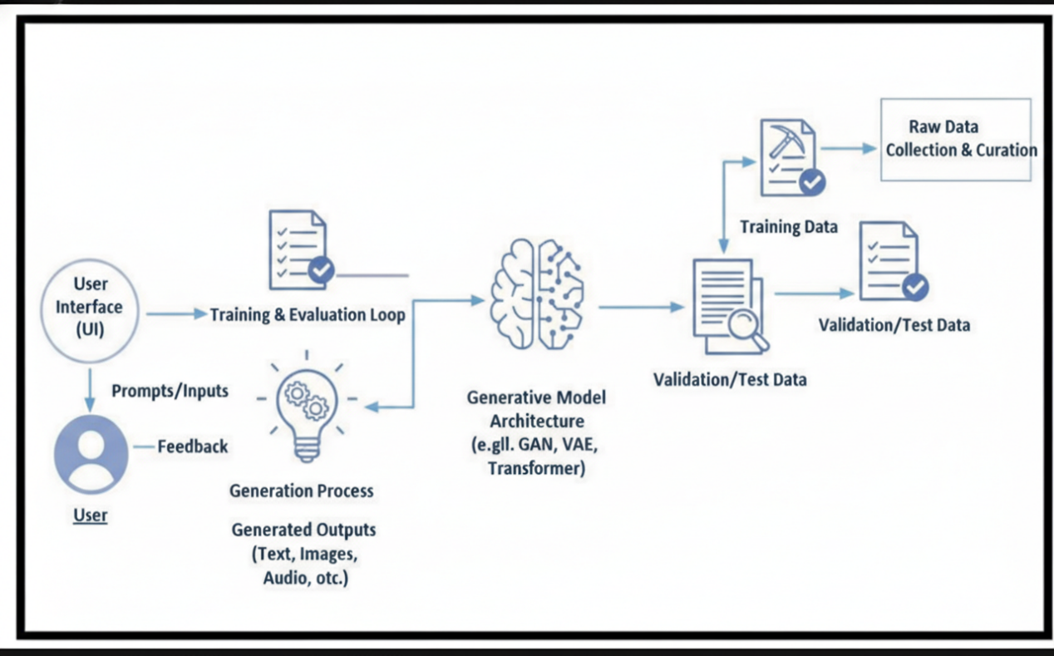

This layer provides interaction between users and the system through a Gradio web interface. Users can enter raw text, upload JSON files, and apply transformations.

Processing Layer

This layer performs the main data processing operations including:

- JSON parsing
- Type inference
- Key naming conversions
- Data transformations
- AI Analysis Layer

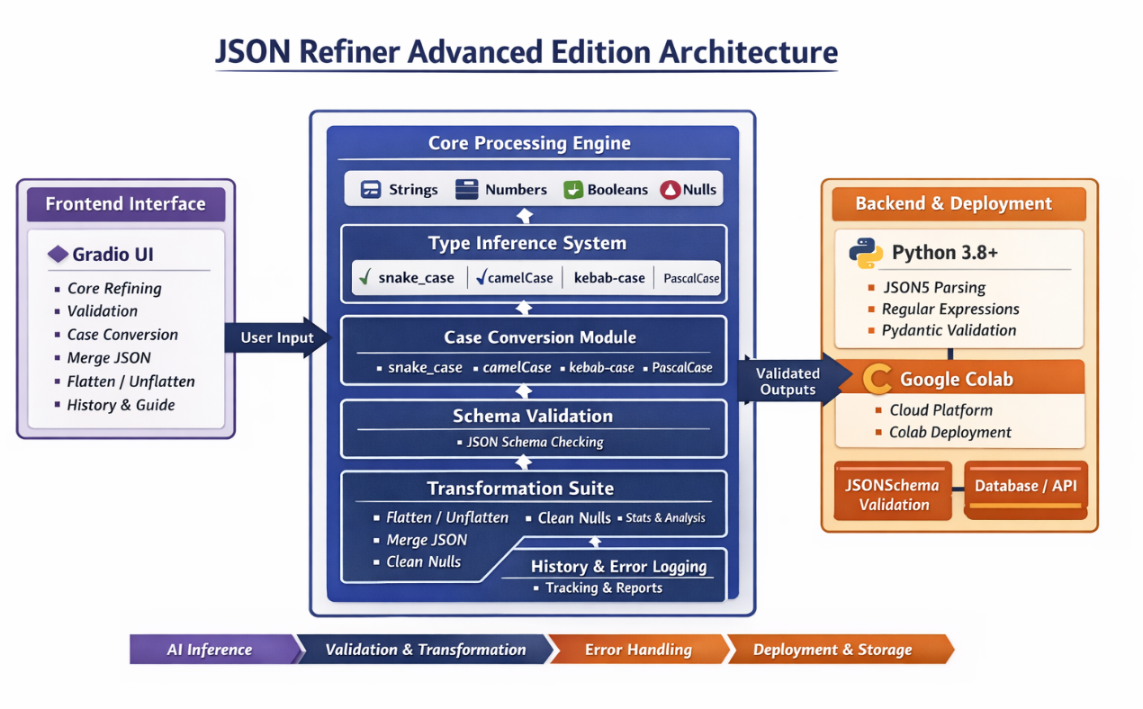
This layer loads the Granite language model using the Transformers library. It analyzes JSON data and generates intelligent summaries and suggestions.

Validation Layer
The validation layer uses JSONSchema to verify whether the input JSON follows a predefined schema. It also provides detailed error messages when validation fails.

7.Module Design

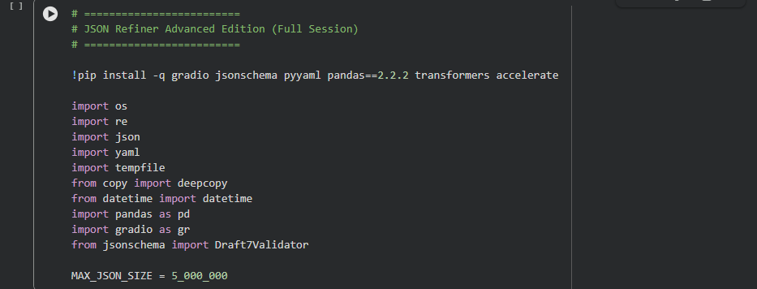

  - AI Model Module

Function: load_granite()

Purpose:

- Load the Granite AI model
- Enable intelligent JSON analysis
- The AI model generates useful insights such as:
- JSON data structure summaries
- Potential data issues
- Recommendations for improvement

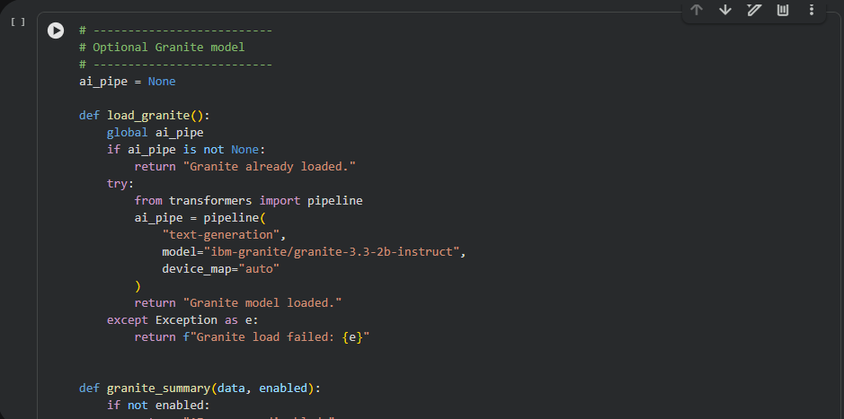

  - JSON Parsing Module

Function: parse_kv_text()
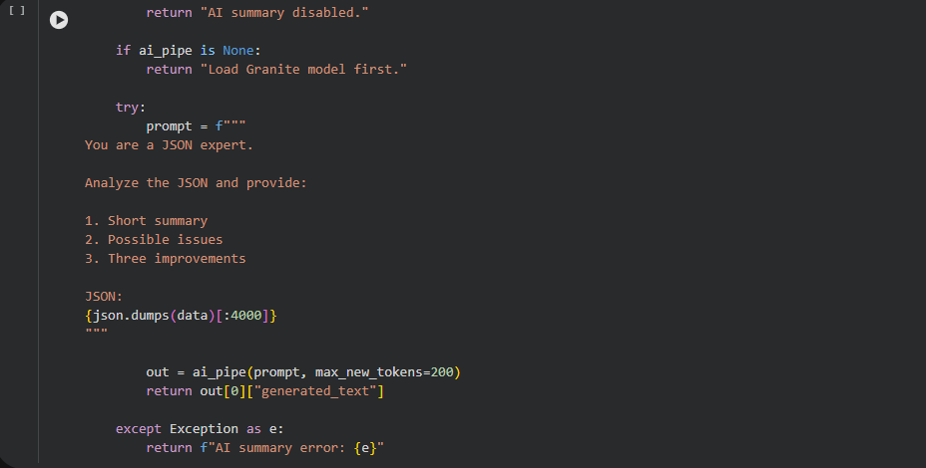
This module converts raw key-value text into structured JSON format.
Example input:

name: John
age: 28
active: true
score: 95.5
Converted JSON:
Copy code

{
"name": "John",
"age": 28,
"active": true,
"score": 95.5
}
The parser also detects syntax errors such as:
Missing colon
Empty keys
Invalid formatting

- Type Inference System

The Type Inference System is one of the most important components of the JSON Refiner Advanced Edition. Its primary purpose is to automatically detect the correct data type of values provided in the input key-value text and convert them into appropriate JSON data types.

In traditional data processing workflows, users must manually specify the data types for each value. This manual process is time-consuming and increases the possibility of human error. The type inference system eliminates this issue by intelligently identifying and assigning the correct data type during the JSON conversion process.

When users provide input data in a simple key: value format, the system analyzes each value and determines whether it represents an integer, floating-point number, boolean value, null value, array, object, or string. This detection is performed using a combination of pattern matching, conditional checks, and Python's built-in type conversion mechanisms.

The type inference process begins by cleaning and trimming the input value to remove unnecessary whitespace. The system then checks whether the value represents a null type. Keywords such as null, none, nil, undefined, and n/a are automatically converted into the JSON null value. This ensures that missing or undefined data is handled correctly.
Next, the system detects boolean values. Words such as true, false, yes, no, on, and off are automatically interpreted as boolean values (true or false). This allows the system to properly represent logical conditions within JSON data structures.

The type inference module also detects numeric values. If the input value contains only digits, it is converted into an integer. If the value contains a decimal point, it is interpreted as a floating-point number. This ensures that numeric values are correctly stored as numbers rather than strings, which improves data processing and analysis.

Another important capability of the system is the ability to detect arrays and objects. If the input value starts with square brackets [ ], the system attempts to parse it as a JSON array. Similarly, if the value begins with curly braces { }, it is treated as a JSON object. This feature enables users to include complex data structures within the key-value input format.

If the value does not match any of the above patterns, it is treated as a string value by default. This ensures that all input data can be processed without causing errors. The final output contains correctly typed JSON values that are ready for further processing or validation.

Overall, the type inference system significantly improves the efficiency and accuracy of JSON data processing. By automatically detecting and assigning appropriate data types, the system reduces manual effort, prevents data inconsistencies, and ensures that the generated JSON output follows standard data representation practices.

Function: infer_type()
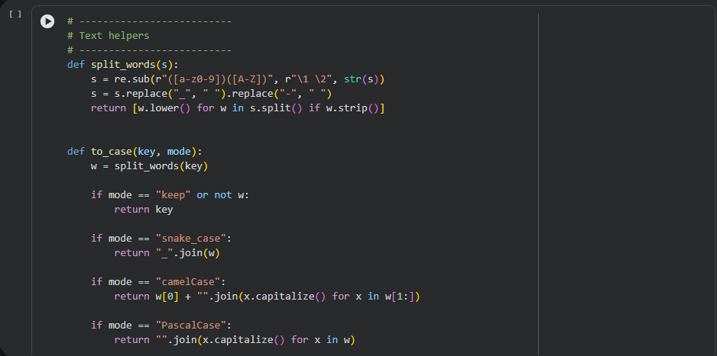

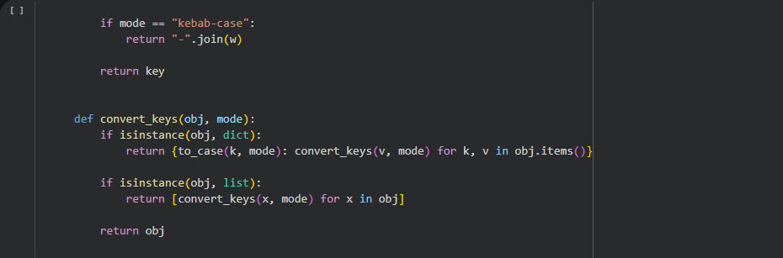

This module automatically detects the correct data type of values.

Supported data types include:

- Integer
- Float
- Boolean
- Null
- Object
- Array
- String

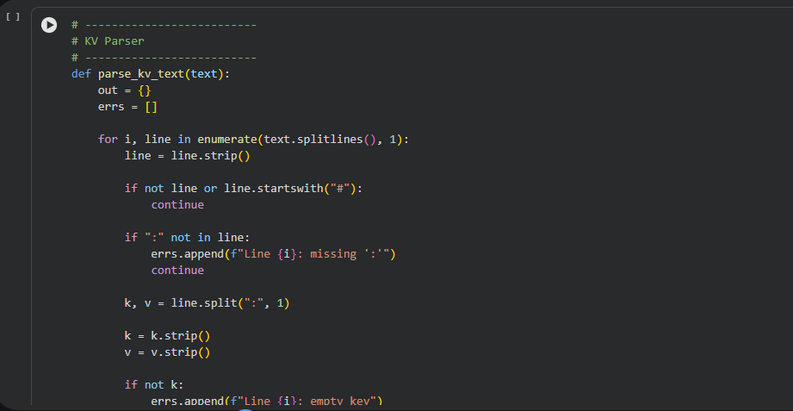

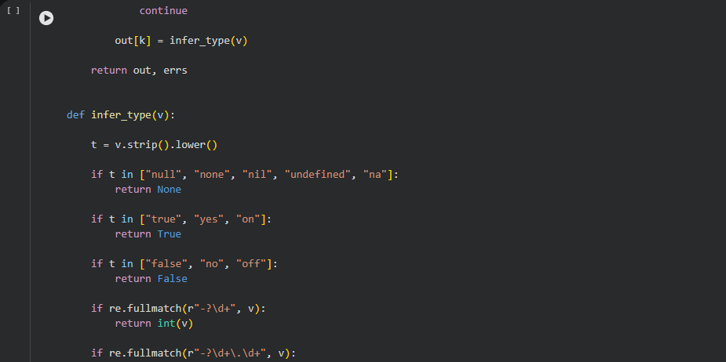

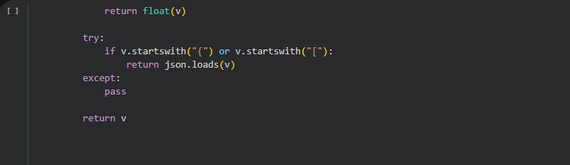

Example:
Input:

age: 25
active: true
Detected output:

age -> Integer
active -> Boolean

Automatic type detection reduces manual data correction.

- Key Case Conversion

Key Case Conversion is another important feature of the JSON Refiner Advanced Edition. In many real-world applications, JSON data originates from multiple sources such as APIs, databases, and configuration files. Each source may follow different naming conventions for keys, which leads to inconsistencies in the data structure. These inconsistencies make it difficult to maintain uniform coding standards and can create challenges when integrating multiple systems.

The key case conversion module solves this problem by allowing users to convert JSON keys into standardized naming formats. The system supports multiple case styles commonly used in software development. These include snake_case, camelCase, PascalCase, and kebab-case. By converting keys into a consistent format, the system ensures better readability, maintainability, and compatibility across different applications.

The conversion process begins by analyzing the original key name and breaking it into individual words. This is done using regular expressions that detect boundaries such as spaces, underscores, hyphens, or uppercase letter transitions. For example, a key such as FirstName can be split into two words: First and Name. Once the words are separated, the system applies the appropriate formatting rules based on the selected case style.

In snake_case, all letters are converted to lowercase and words are separated using underscores. For example, FirstName becomes first_name. This format is widely used in Python programming and database column names.

In camelCase, the first word remains lowercase while the first letter of each subsequent word is capitalized. For example, first_name becomes firstName. This naming style is commonly used in JavaScript and many web APIs.

In PascalCase, the first letter of every word is capitalized. For example, first_name becomes FirstName. This format is frequently used in object-oriented programming languages such as C# and Java for class names.
In kebab-case, all letters are converted to lowercase and words are separated using hyphens. For example, FirstName becomes first-name. This style is commonly used in URLs and configuration files.

The key conversion module processes JSON objects recursively, which means that nested JSON structures are also converted automatically. This ensures that the entire JSON document follows the selected naming convention consistently.

By providing flexible case conversion options, the JSON Refiner system helps developers maintain uniform coding standards across different projects. It also simplifies data integration between systems that follow different naming conventions. Overall, the key case conversion module improves data consistency, readability, and maintainability in JSON-based applications.

The system supports multiple naming conventions for JSON keys.

Functions used:

- split_words()
- to_case()
- convert_keys()
- Supported formats include:
- snake_case
- camelCase
- PascalCase
- kebab-case

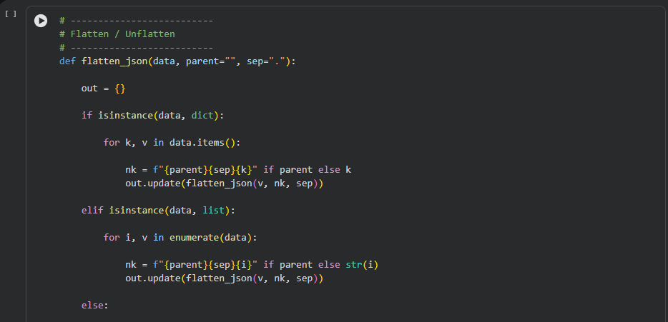

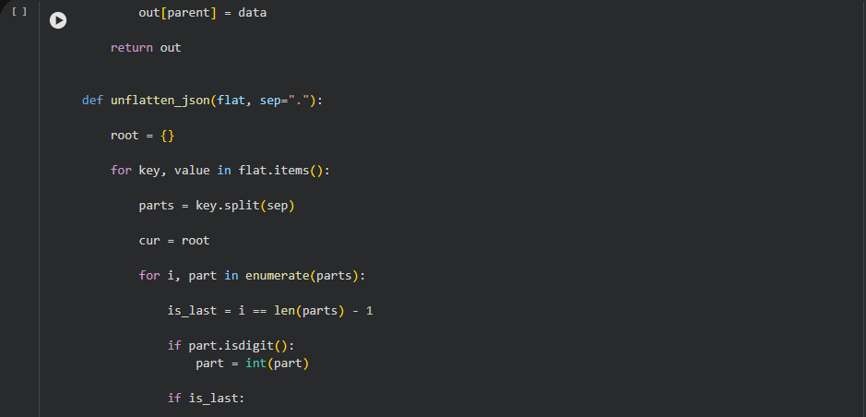

Example:
Input key:

FirstName
Converted to snake_case:

first_name
This feature is particularly useful for API standardization.

- Flatten and Unflatten Module

Functions used:

- flatten_json()
- unflatten_json()
- Flattening converts nested JSON structures into dot notation format.

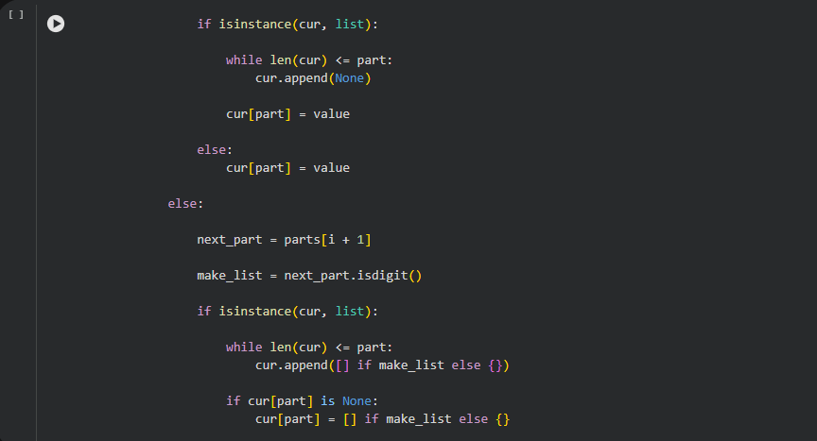

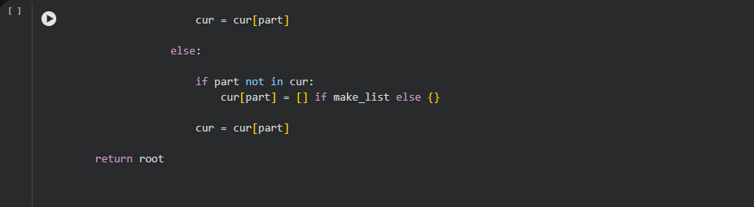

Example:
Input JSON:

{
"user": {
"name": "John",
"profile": {
"age": 28
}
}
}
Flattened output:

user.name
user.profile.age

This format simplifies data analysis and spreadsheet conversion.
Unflattening restores the original nested structure.

- Schema Validation

Schema validation is an important process used to ensure that the structure and format of data follow a predefined schema or set of rules. In systems that process structured data such as JSON, XML, or database records, schema validation helps verify whether the input data matches the expected structure before it is processed further. This helps prevent errors, improves reliability, and ensures data consistency throughout the application.

In many modern applications, especially those involving APIs and data transformation tools, schema validation acts as the first layer of data verification. When a user submits data, the system checks whether the required fields are present, whether the data types are correct, and whether the values satisfy certain constraints. For example, a field that expects a number should not accept text values, and mandatory fields should not be left empty.

One major advantage of schema validation is improved error detection. Instead of allowing incorrect data to move through the system and cause failures later, validation detects problems at the earliest stage. This makes debugging easier and reduces the risk of system crashes. Additionally, schema validation ensures interoperability between systems by guaranteeing that data exchanged between components follows the same format.

In the context of JSON processing systems, schema validation ensures that the JSON structure matches the expected schema definition. This includes validating nested objects, arrays, field types, and optional versus required fields. Many frameworks and libraries provide built-in validation tools that automatically check the input against the schema and generate meaningful error messages when validation fails.

Another benefit of schema validation is improved maintainability. When a schema is clearly defined, developers can understand the data structure more easily and update the system without breaking existing functionality. It also helps maintain documentation for the system because the schema itself acts as a reference model for the data.

Overall, schema validation plays a crucial role in maintaining data integrity and system stability. By enforcing structured rules on incoming data, it ensures that the system processes only valid and well-formed data. This reduces errors, improves system performance, and supports scalable and reliable software development.

The system uses JSONSchema to verify that JSON data follows a predefined structure.

Example schema:

{
"type": "object",
"properties": {
"name": {"type": "string"},
"age": {"type": "integer"}
}
}
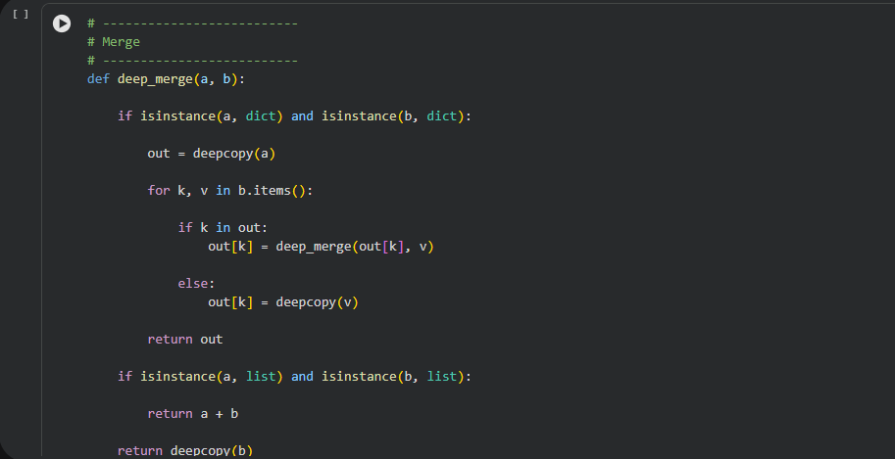

If the input data does not match the schema, the system reports validation errors.
- Error Handling System

Error handling is an essential component of the JSON Refiner Advanced Edition because the system must process different types of input data that may contain formatting mistakes, structural issues, or invalid values. Without proper error handling, incorrect input data could cause system crashes or produce invalid outputs. Therefore, the JSON Refiner system implements a comprehensive error detection and reporting mechanism to ensure reliability and data integrity.

The system is designed to identify and handle multiple categories of errors during different stages of JSON processing. One of the most common issues occurs during the parsing stage, where the input key-value text may contain syntax mistakes such as missing colon separators, empty keys, or incorrectly formatted values. The parser module checks every line of the input text and verifies whether it follows the required key: value format. If an error is detected, the system records the issue and displays a clear message indicating the exact line number where the error occurred.

Another important aspect of error handling involves detecting duplicate keys in the input data. Duplicate keys can create conflicts during JSON conversion and lead to data loss. To prevent this problem, the system tracks previously processed keys and generates warnings whenever a duplicate key is detected. The user is then notified so that the issue can be corrected before generating the final JSON output.

The system also performs validation checks to ensure that the JSON structure conforms to a predefined schema. Using the JSONSchema validation library, the system compares the generated JSON data with a specified schema definition. If the data violates the schema rules, the system generates detailed validation errors that clearly explain which field does not match the required type or structure.

In addition, the system includes protection mechanisms to prevent performance issues caused by extremely large input files. A maximum JSON file size limit of 5MB has been defined to ensure that the system operates efficiently without consuming excessive memory resources. If the file size exceeds this limit, the system rejects the input and provides a warning message.

Overall, the error handling system ensures that the JSON Refiner platform remains stable, secure, and user-friendly. By detecting errors early and providing meaningful feedback, the system helps users correct problems quickly and generate accurate JSON outputs.

The system includes robust error detection and handling mechanisms.

Types of errors detected include:

- Invalid JSON format
- Missing key-value delimiter
- Duplicate keys
- Schema violations
- File size limits

Maximum allowed JSON size:
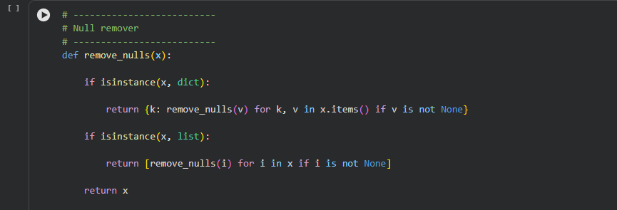
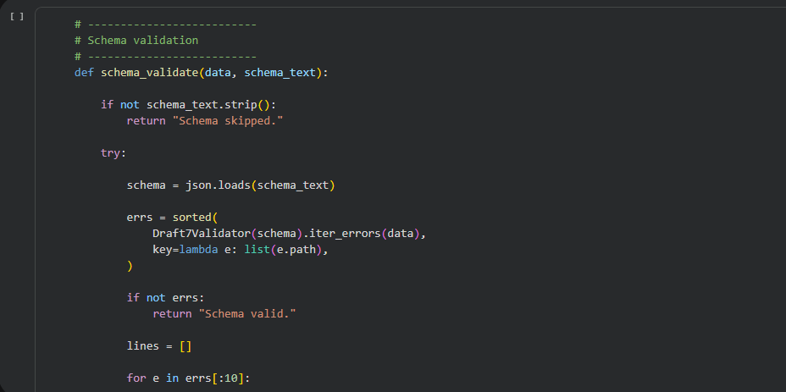

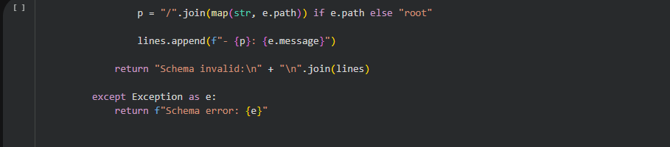

MAX_JSON_SIZE = 5MB
This prevents system overload.

- User Interface Design

The application uses Gradio to create a simple and interactive web interface.

Key features include:

- JSON input editor
- File upload functionality
- Transformation options
- AI analysis button
- Output display panel

Advantages:
- Browser-based interface
- No software installation required
- Easy interaction
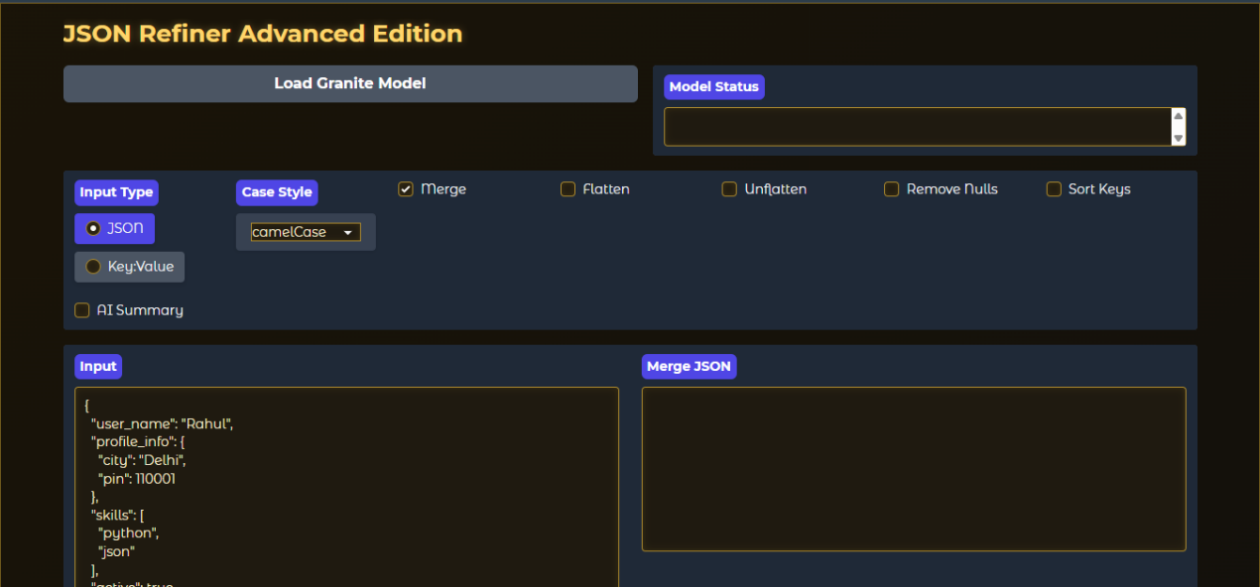

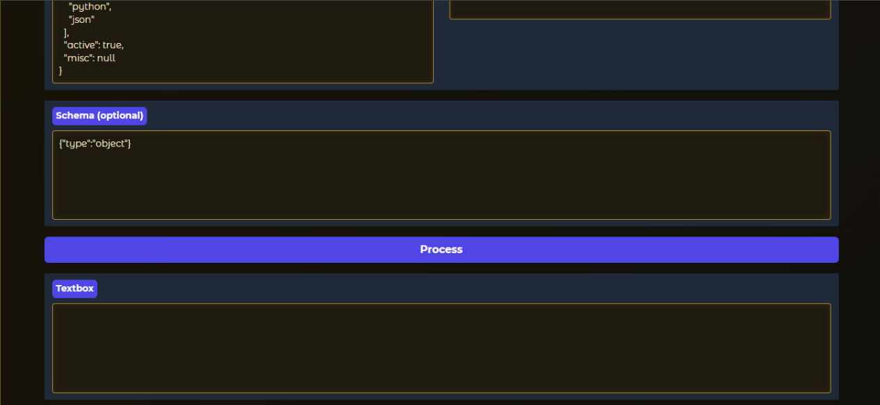

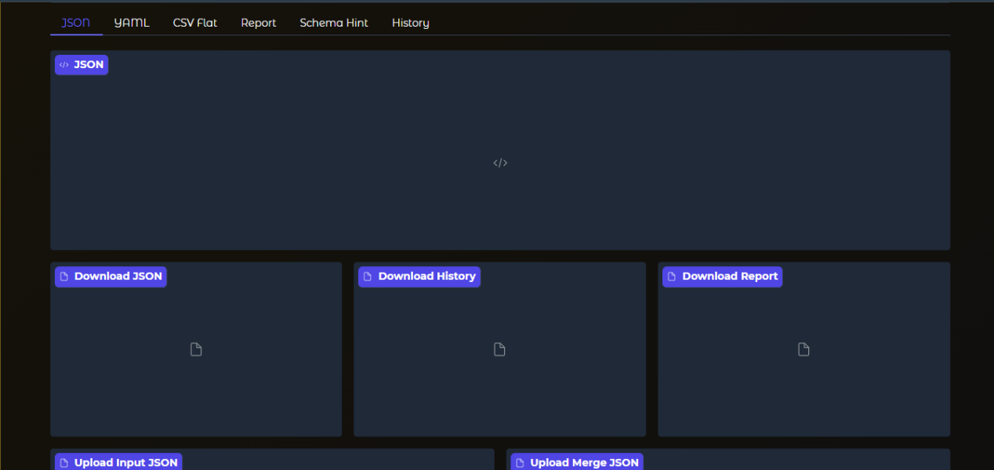
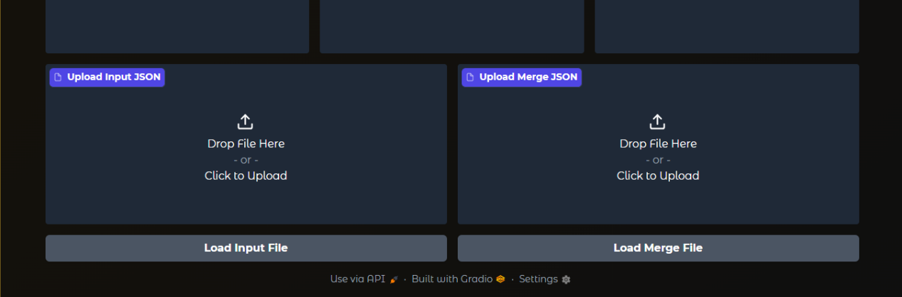

- Implementation Details

The implementation of the JSON Refiner Advanced Edition was carried out using the Python programming language due to its strong support for data processing, machine learning libraries, and web application development. Python provides a wide range of tools that simplify the development of data-driven applications and allow rapid prototyping of complex systems.

The system was developed in a cloud-based environment using Google Colab, which provides a convenient platform for executing Python code without requiring local installation of software. Google Colab also offers access to cloud computing resources, making it suitable for running machine learning models and web-based interfaces.

The implementation process began with the installation of the required dependencies using the Python package manager pip. Libraries such as Gradio, JSONSchema, Pandas, Transformers, and PyYAML were installed to support different functionalities of the system. These libraries collectively provide capabilities for data manipulation, schema validation, AI-based text generation, and web interface development.

After setting up the environment, the core modules of the system were implemented. The JSON parsing module was developed to convert raw key-value text into structured JSON objects. This module includes a type inference system that automatically detects whether values represent integers, floating-point numbers, booleans, null values, arrays, objects, or strings. The type inference logic significantly reduces the need for manual data correction.

Next, the key normalization module was implemented to standardize naming conventions across JSON structures. Using regular expression techniques, the system converts keys into different formats such as snake_case, camelCase, kebab-case, and PascalCase. This feature ensures consistency in API responses and configuration files.
Additional transformation modules were implemented to support operations such as flattening nested JSON structures, unflattening dot-notation keys, merging multiple JSON objects, and removing null values. These transformations allow users to restructure their JSON data according to different application requirements.

The user interface was built using Gradio, which enables rapid development of interactive web interfaces directly from Python code. The interface consists of multiple functional tabs that allow users to perform different operations including JSON refinement, schema validation, case conversion, JSON merging, flattening and unflattening, transformation history tracking, and usage guidance.

Finally, the entire system was integrated and tested to ensure smooth interaction between modules. The implementation successfully demonstrates how Python-based tools and AI technologies can be combined to build a powerful and user-friendly JSON processing platform.

The system was implemented using Python and deployed using Google Colab.

Implementation steps:

- Install required dependencies
- Import necessary libraries
- Initialize processing modules
- Accept user input
- Generate refined JSON output

Dependencies installed:

pip install gradio jsonschema pyyaml pandas transformers accelerate.

- Testing and Results

The system was tested with multiple datasets including:

- API responses
- Configuration files
- CSV converted data
- Nested JSON structures

Results show that the system successfully:

- Converts text into structured JSON
- Applies naming convention transformations
- Automatically detects data types
- Flattens nested structures
- Generates AI-based insights

16. Advantages of the System
- Automated JSON processing
- AI-based analysis
- Schema validation
- Easy-to-use web interface
- Flexible data transformations
- Detailed error detection

- Limitations

Some limitations include:

- Large datasets may require optimization
- AI analysis depends on model availability
- Internet connection required for model download

- Future Enhancements

Future improvements may include:

- Integration with databases
- REST API support
- JSON visualization dashboards
- Support for XML and CSV formats
- Enhanced AI recommendations

Conclusion:

The JSON Refiner Advanced Edition project successfully demonstrates the development of an intelligent platform for JSON data processing and transformation. As modern software systems increasingly rely on JSON for data exchange, the need for efficient tools that can process and standardize JSON structures has become more important than ever.

This project addresses several common challenges faced by developers and data analysts when working with JSON data. These challenges include inconsistent key naming conventions, incorrect data types, complex nested structures, and lack of proper validation mechanisms. By automating these processes, the JSON Refiner system reduces the amount of manual work required to prepare JSON data for production environments.

One of the key strengths of the system is its modular architecture, which separates the processing, validation, transformation, and interface components. This modular design makes the system easy to maintain and extend with additional features in the future. The integration of Python libraries such as Gradio, Pandas, JSONSchema, and Transformers provides a powerful technological foundation for building advanced data processing applications.

The system also demonstrates the potential of integrating artificial intelligence into data management workflows. By using the Granite AI model through the Transformers library, the platform can analyze JSON data and generate useful summaries and recommendations. This AI-based functionality enhances the overall usability of the system and provides additional insights into complex data structures.
Another important achievement of the project is the development of a user-friendly web interface that allows users to perform complex JSON transformations without requiring extensive programming knowledge. Through its interactive Gradio interface, the system enables users to easily input data, apply transformations, validate structures, and view refined JSON outputs.

In conclusion, the JSON Refiner Advanced Edition provides a comprehensive solution for JSON data processing, validation, and transformation. The project highlights how automation and artificial intelligence can significantly improve data quality, reduce manual effort, and enhance productivity in modern software development workflows. With further enhancements such as database integration, API support, and advanced visualization features, the system has the potential to evolve into a full-scale data processing platform capable of handling diverse data formats and large-scale data transformation tasks.

